2019 CURVE TRACER CIRCUIT DESCRIPTION
(20201111)

Basic principle of operation
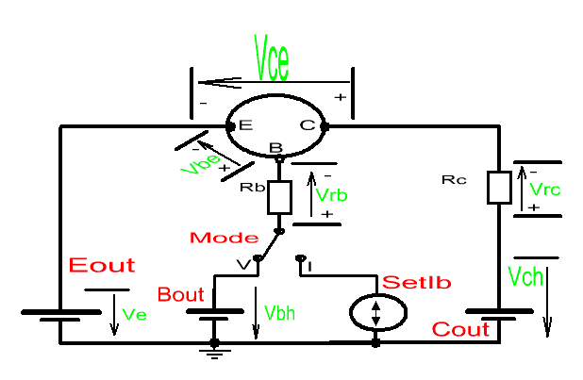
The system uses three independent voltage sources to respectively drive each of the three terminals of a transistor under test. The correct bias for measuring a P or N type transistor is obtained by setting the voltage level of each source. Although the voltage sources can only output positive voltages with respect to ground, the sources can act as both a current sink and a current source. The resistors RC/RB are also built into the system and different values can be automatically selected to allow measurement at different currents.

For example, to measure NPN the system sets the E channel voltage source to +2.5V, the C channel voltage source to +35V, and the B channel voltage source to +10V, so that the NPN transistor gets the correct bias for measurement. When measuring a PNP transistor, the E channel is set to +35V, the C channel to +2.5V, and the B channel to +25V, to make the PNP transistor get the correct bias.

The system can measure the 7 voltages shown in green in the figure above Ve/Vbh/Vch/Vbe/Vce/Vrc/Vrb and then calculate the Ic/Ib of the transistor under test, in accordance with whichever values of resistors RC/RB were selected.

In order to satisfy BJT transistor measurement requirements, the B channel additionally supports a constant current output mode. Detailed circuitry descriptions follow below.
1. Three-channel voltage output
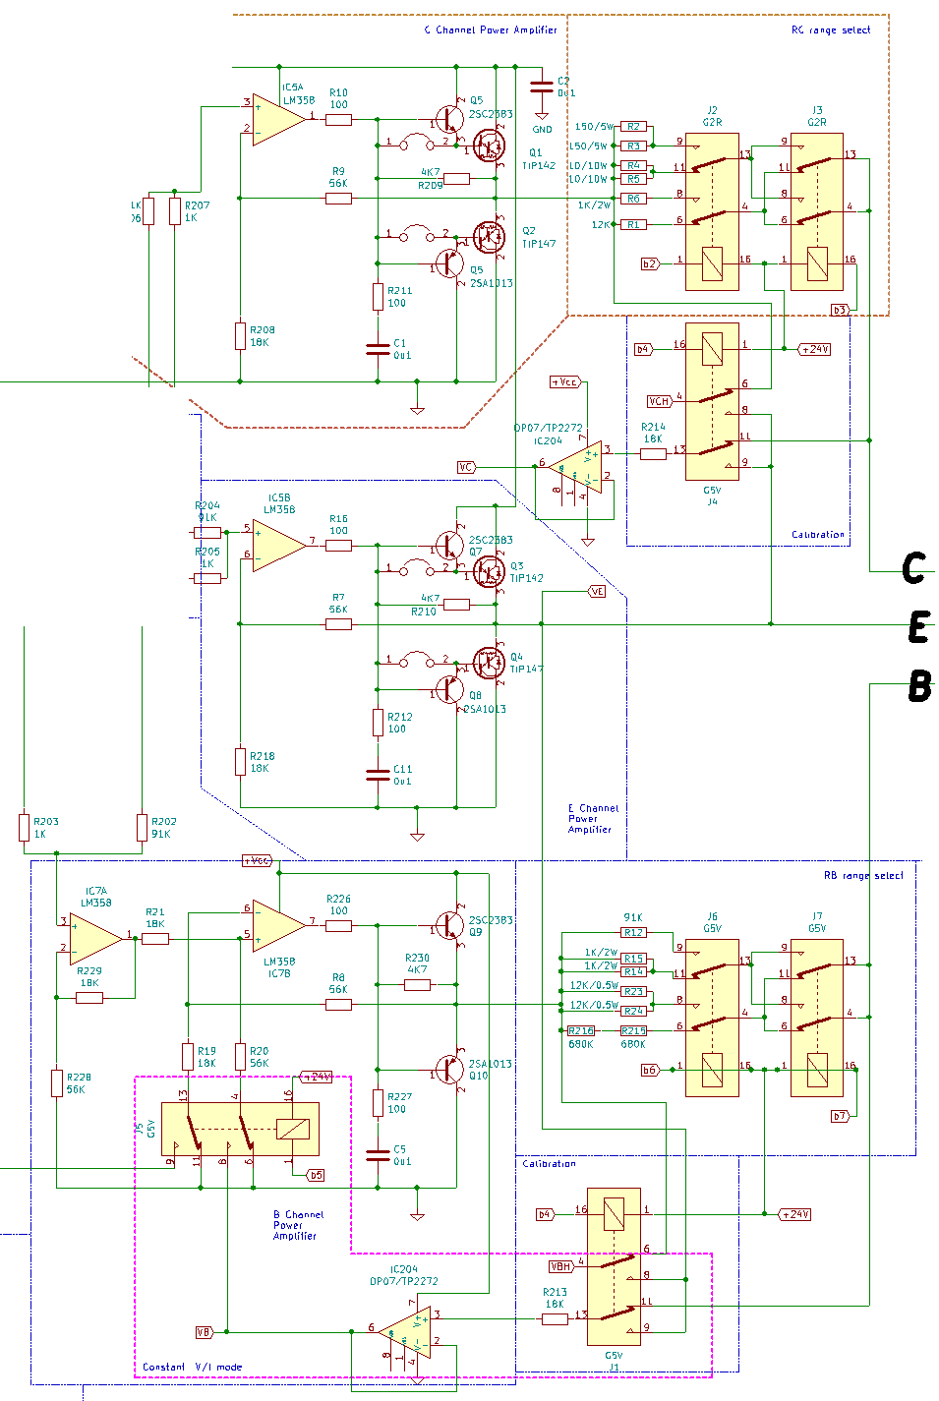
Each of the three voltage output channels is a power amplifier consisting of an op-amp feeding into a voltage follower. Because these are DC amplifiers which do not need to deal with crossover distortion, it is sufficient to work in pure class B. The C/E channels need to handle high currents so therefore the output transistors are in Darlington configuration. The 100Ω+(100Ω+0.1uF) in front of each follower stage dampens any ringing. The gain of each power amplifier calculated at the op-amp is (56KΩ +18KΩ)/18KΩ = 4.11 times.

The B/C channel outputs are connected to the B/C terminals of the transistor under test through one of 4 current sampling range resistors. OP07 is a high impedance buffer used to read the voltage behind each current sampling resistor.

The B channel is more complicated because it needs to work in either constant voltage or constant current output mode, depending upon the type of measurement to be made. Switching from voltage mode to current mode is accomplished by activating relay J5, and the figure above shows the constant voltage mode. The amplification factor of IC7b is only 56KΩ/18KΩ = 3.11 times and so IC7a having a gain of (18KΩ+56KΩ)/56KΩ = 1.32 times has been included as compensation, to ensure that the total gain will be 3.11*1.32 = 4.11 times, same as the C/E channels.

When the relay J5 pulls in, then the channel B amplifier becomes a voltage-controlled constant current source and an offset voltage of about 6V is mixed in. This way when the input terminal receives 0~12V from the DAC, then the output can seamlessly transition from a constant current output in the positive direction to a constant current output in the negative direction.

2. Power supply and protection circuit
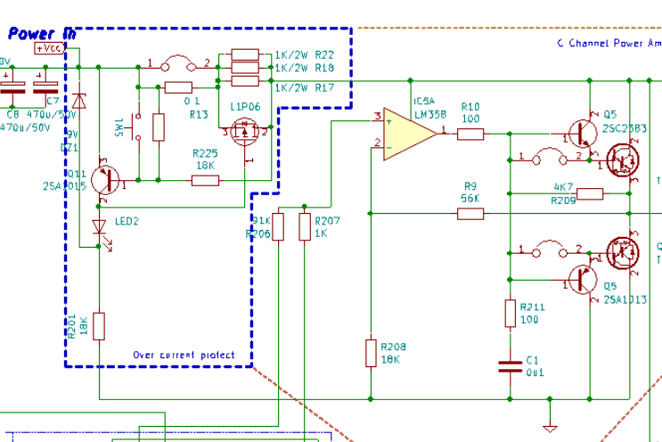
Vcc is supplied to the Channel C/E power amplifiers after passing through an overcurrent protection circuit. The B channel is connected in series with RB which has a minimum resistance of 500Ω so even if it is short-circuited then the current would be less than 80mA. Therefore the B channel does not need to be protected.

The protection circuit is as shown in the blue box of the above diagram. 2SA1015 (PNP) and 11P06 (PMOS) form an over-current protection with positive feedback. The over-current detection resistor is composed of the series combination of R13 0.1Ω + PMOS-transistor on-resistance. Normally the 2SA1015 does not conduct, the PMOS transistor gate to source voltage Vgs reaches 9V, and so the PMOS transistor is completely turned on, yielding a very low resistance between D & S (about 0.1～0.3Ω).
In case of over-current, the voltage between D & S exceeds 0.6V causing 2SA1015 to turn on and take away gate-drive from 11P06. This cause Vgs to drop and consequently Rds rises, turning 2SA970 on even more in a positive feedback. As a result, the PMOS transistor quickly turns off and then the left-over current supplied by the 3 parallel 1KΩ 2W resistors is only 100mA. Once the overcurrent condition is removed and the current drops below 1mA, the circuit automatically recovers.
When there is overcurrent, LED2 will light up, indicating that overcurrent has occurred. The 9V Zener diode protects the gate to source voltage of the PMOS transistor to avoid damaging it.

3. Measuring circuit
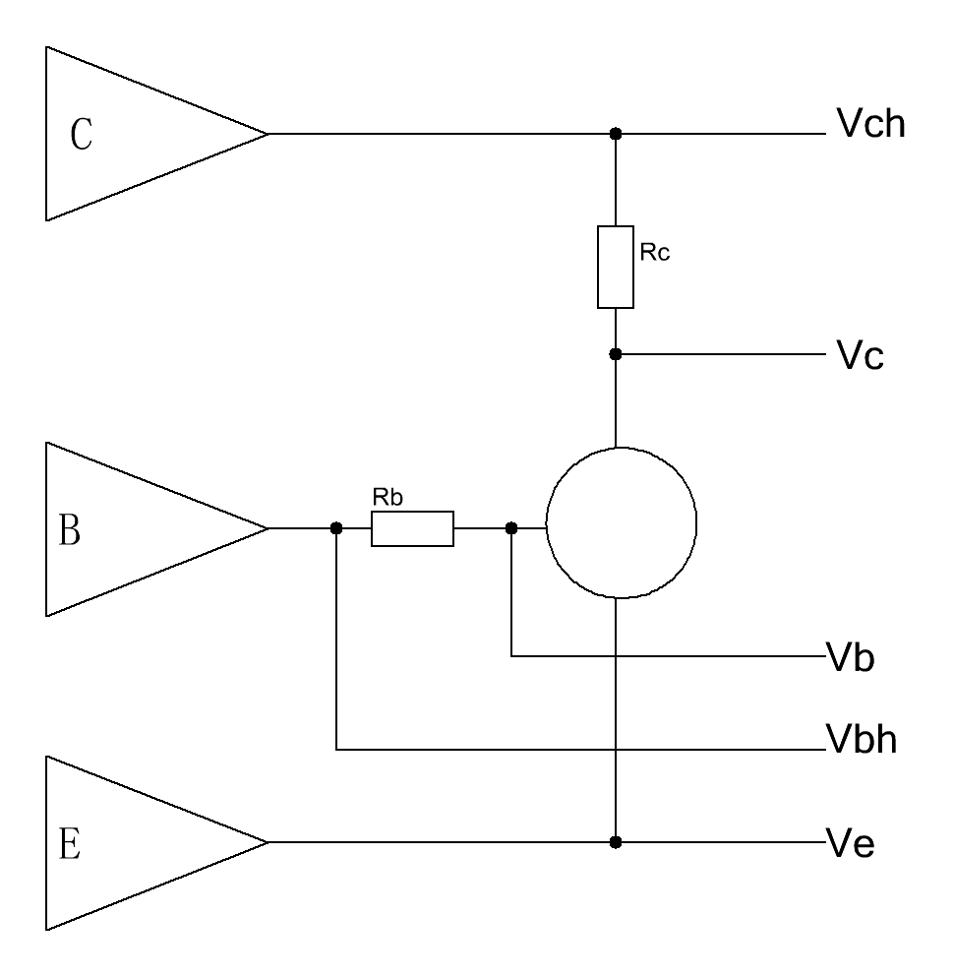
The measurement circuit diagram above shows the 5 voltages Vch/Vc/Vb/Vbh/Ve which can be measured and used along with the values of RB/RC to calculate parameters such as Ib, Ic, Hfe, Vbe, Vgs, and transconductance. The acquisition of these voltages from the 3 channel amplifier is shown in the schematics below.
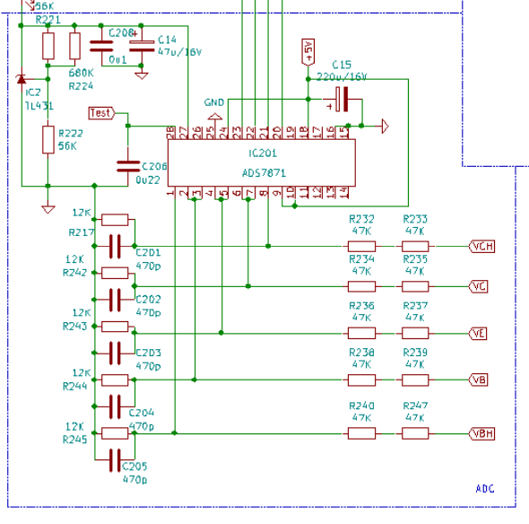
Each of the 5 voltages is routed to the ADC through its own separate voltage divider network composed of 47KΩ+47KΩ:12KΩ+470pF (some boards have 47KΩ+47KΩ:12.4KΩ) via the correction amplifier OPO7 fed from relay J1/J4. The ADC chip is an ADS7871 which has eight 14bit channels and supports differential and PGA amplification measurements. A TL431 provides the ADC reference voltage of about 4.8V, so the maximum measurable voltage is 4.8*(47 KΩ +47 KΩ +12 KΩ)/12 KΩ = 42V.
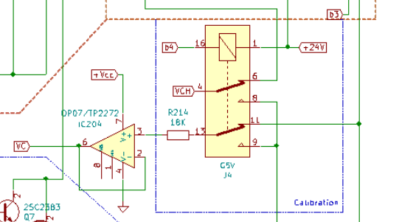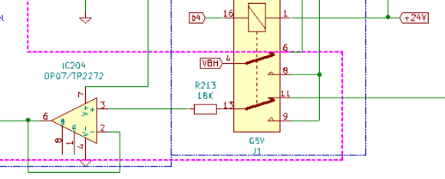
J1 and J4 are calibration relays. When calibration is needed then J1 and J4 are all connected to the Ve terminal, thereby connecting all 5 ADC channels to the same voltage. The system controls the E-channel power amplifier to output different voltages, and obtains the common mode measurement correction coefficients of the four channels Vch/Vc/Vb/Vbh through calculation.

These four correction coefficients are very important for measurement, because the system adopts differential + PGA amplification measurement. Generally, differential measurement requires a very high degree of resistance matching. Otherwise, the higher the common-mode voltage, the greater the error introduced into the measurement. For example, if a resistance with a matching precision of 1% is used and if the common mode voltage is 36V, then the error caused will reach 2*36V*1% reaching 84mV. For Vbe-Ic curve measurement with only 0.7V, the error caused will reach 12%, and the degree of matching is additionally also greatly affected by temperature.

This system adopts a method of calculation and correction. Through the correction coefficient obtained by the above correction, the accurate actual voltage is obtained through calculation. Even if 5% resistance is used, this process can achieve better short term measurement results than 0.1% resistance matching.

4. DAC and relay control Circuit
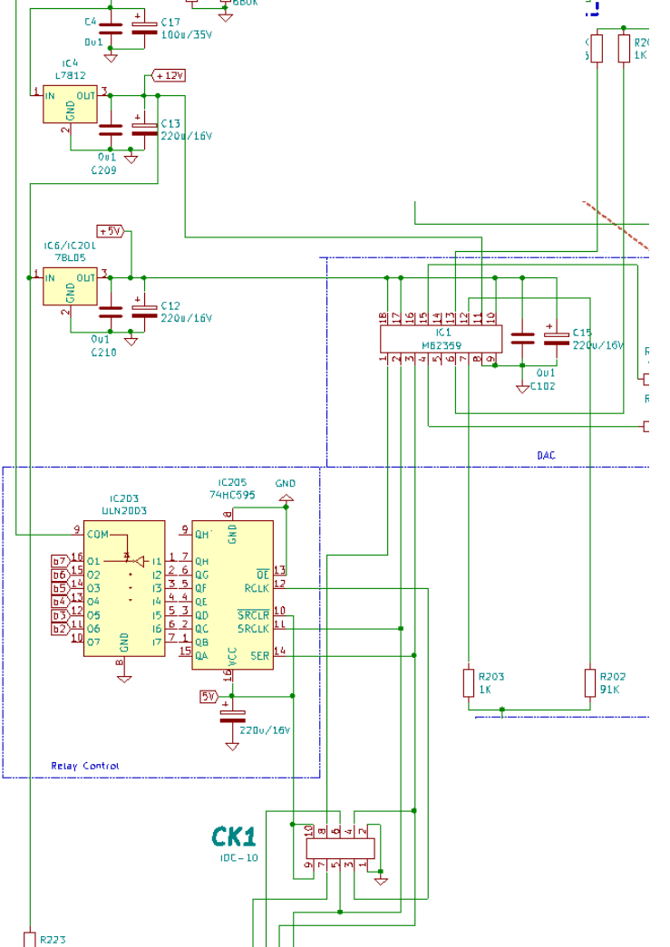
The DAC uses an M62359 which contains an 8-channel 8Bit DAC with buffered outputs. Only 6 channels are used here; pairs of DAC channels are combined through 1KΩ/91KΩ (1KΩ/56KΩ on some boards) and two weighting resistors, thereby providing approximately 14bits of resolution out to each of the 3 amplifiers. The DAC requires two power supplies, one is 12V, and the other is 5V(DAC). The maximum output voltage of the DAC is 12V so after the gain of 4.11 within the power amplifier, the minimum attainable output voltage step or resolution is about 12V/256/91 KΩ /1 KΩ *4.11 = 2.1mV

Relay control uses a 74HC595 feeding into a ULN2003 driver. The 2019 version optimizes the power consumption of the relay. When waiting for measurement, the relay is not energized, which reduces the power consumption.
Each of the ADC/DAC/74HC595 are connected to the MCU board through the IDC-10 cable which also provides +5V power from the main board to the MCU board.

5. MCU circuit board
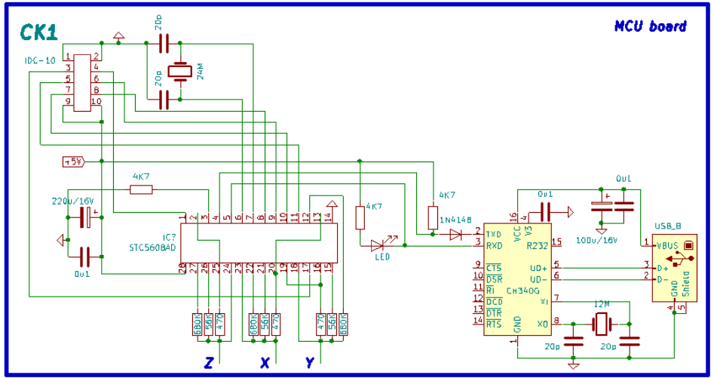
The MCU is an STC12C5608AD which is a 25MHz 1T 8051 clone with ISP programming, 8kB flash, 768 bytes RAM, EEPROM, UART, 10bit AD and several other built-in peripherals.

Communications with the main board are via SPI type serial protocols. The AD port and other IO ports perform transistor-type and pinout identification via the green 14 pin ZIF socket however these inputs don’t have any additional ESD protection so it is wise to discharge any static electricity by touching a finger to the metal case prior to inserting a component into the green ZIF socket.

The PC interface comprises of an CH340C chip (CH340G is also possible) which provides a USB to serial port function. The LED may be seen to shimmer when serial communications are taking place. This chip is powered directly from the USB bus so it will enumerate on the host even when the curve tracer is not powered, however power to the curve tracer is required in order for the application program to communicate with the MCU.

6. Overall circuit
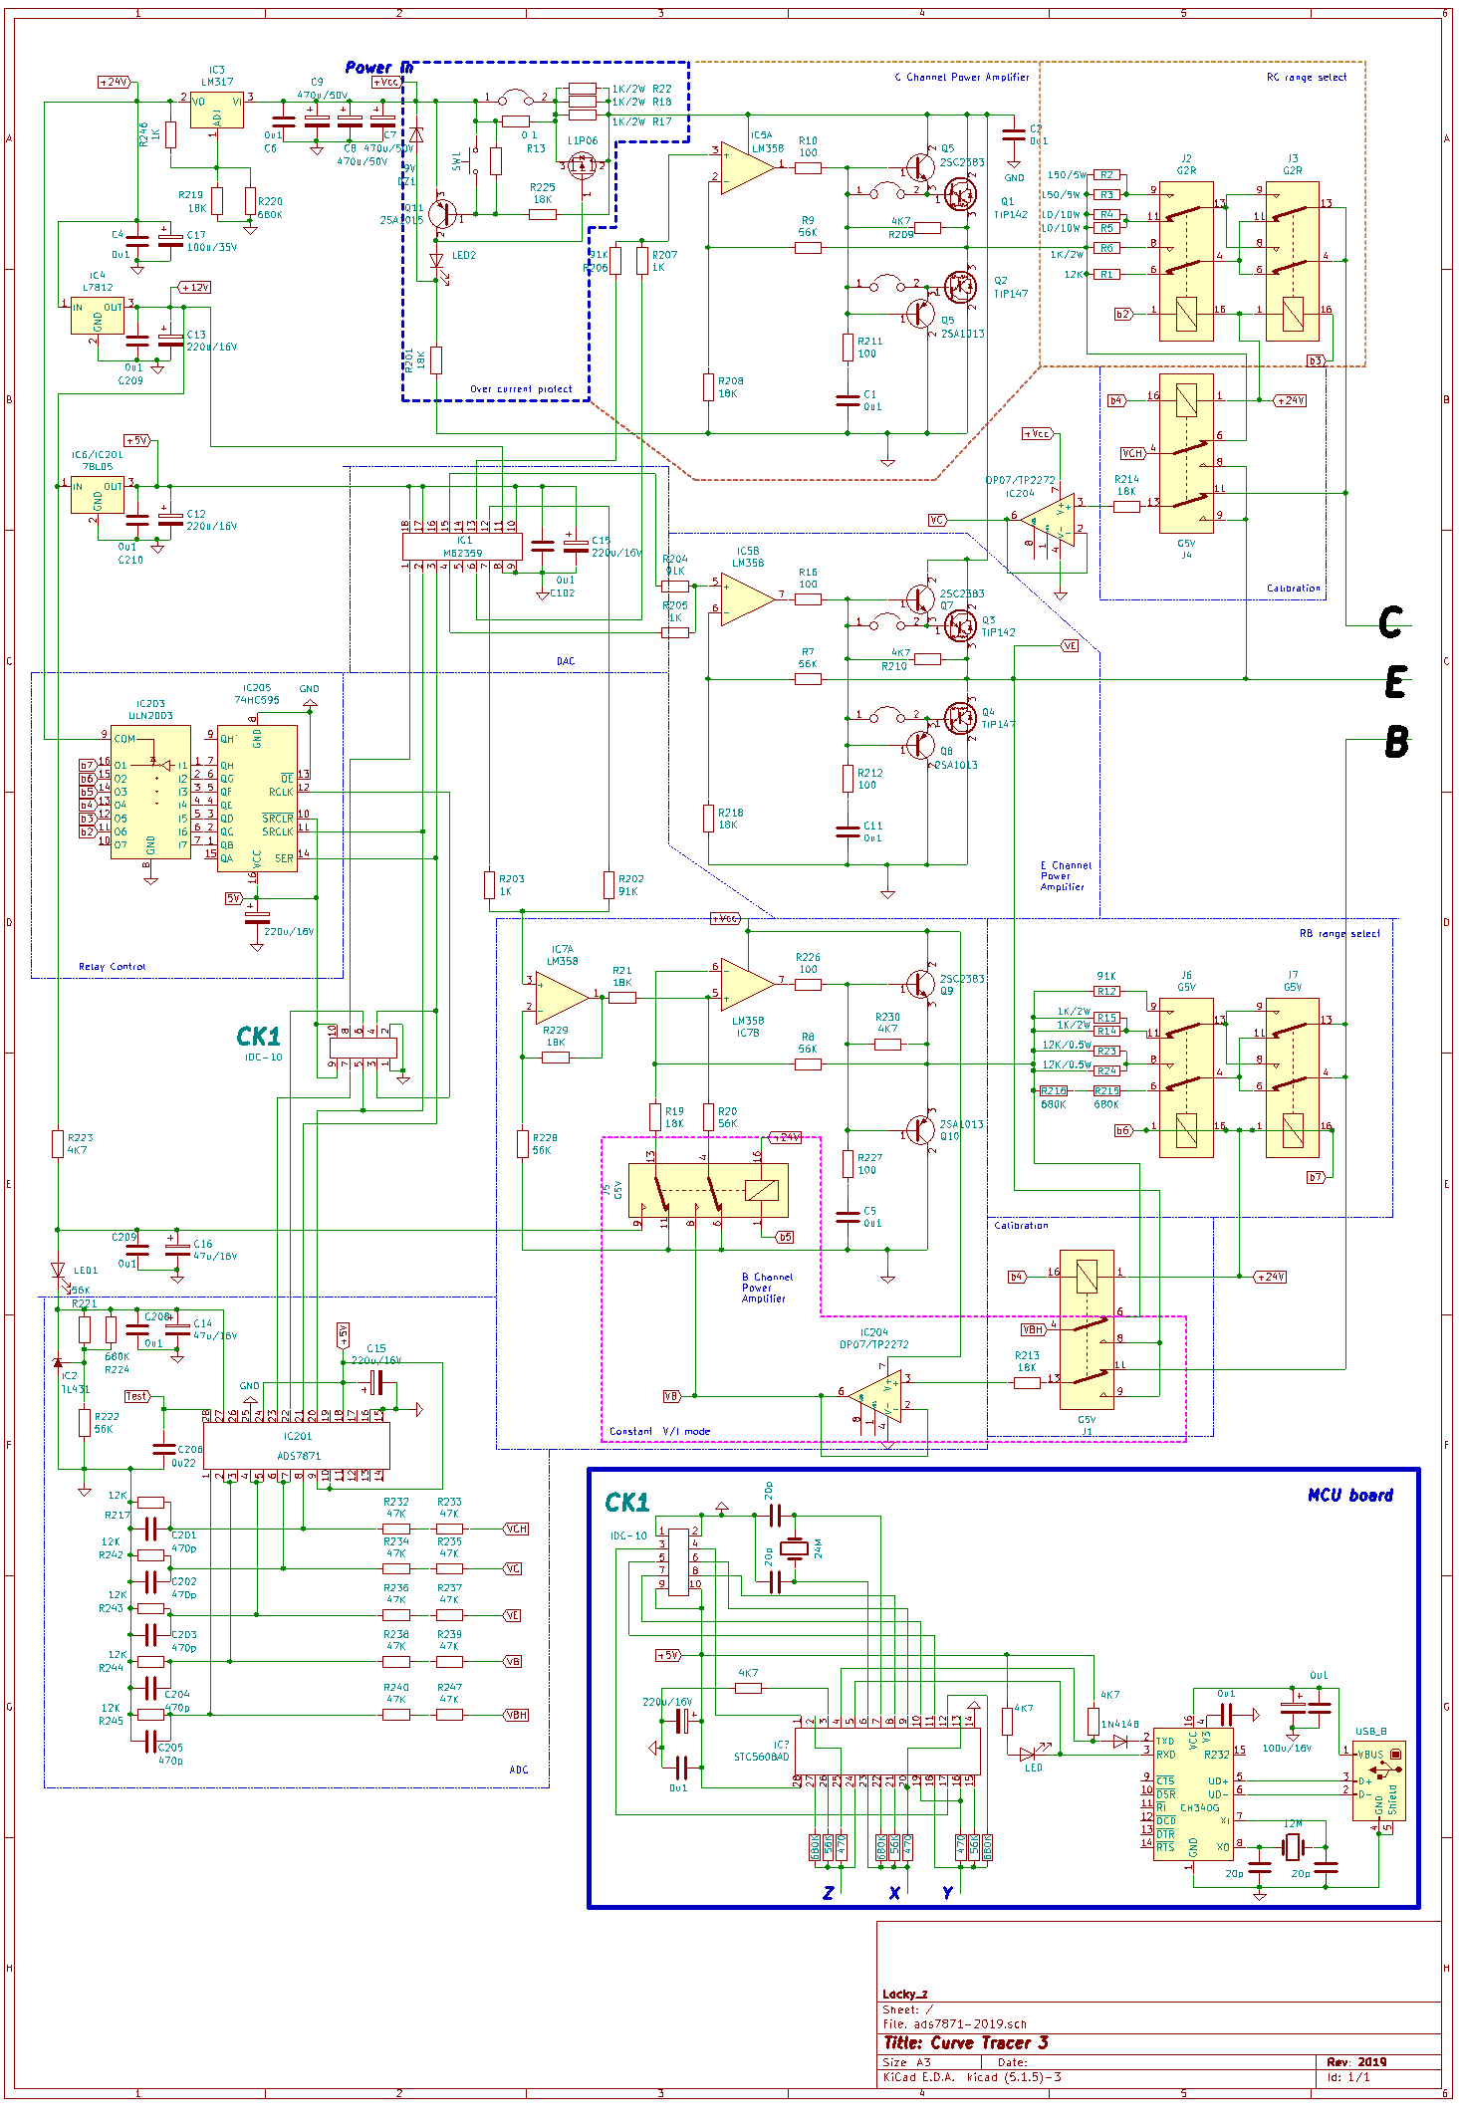
Be aware that some relay pin-outs may not correspond directly with some PCB foil artwork and silk-screen designations.

